User Management-Manual
User Management is ASP.NET Core (6.0), IdentityCore, C#, EF code first web applications which help you to create, update delete, read and manage user information very smoothly with cool UI and firster paging, sorting, and searching functionality. Along with each user's login history. All CRUD operation has been done without full page loading.
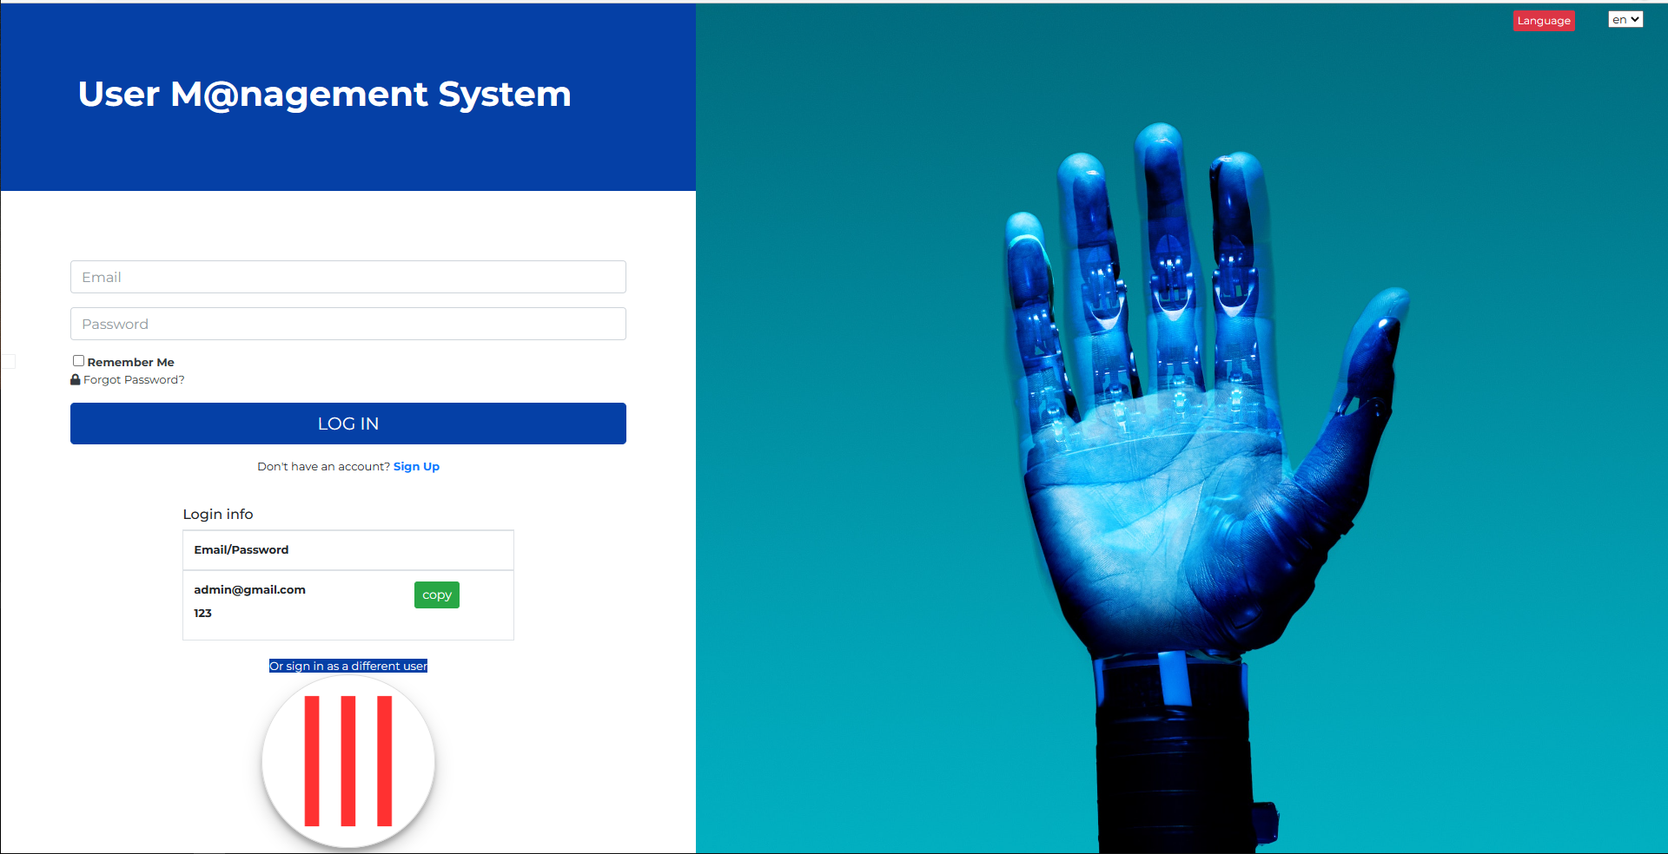

Technologies:
Microsoft Visual Studio Community 2019, ASP.NET Core 6.0, IdentityCore, Entity Framework Code First, MS SQL SERVER 2017, AdminLTE 3.0.5, JavaScript, jQuery data table, bootstrap 4, sweetalert, toastr, Fontawesome etc.

Prerequisite Application:
Microsoft Visual Studio Community 2019, Dot Net Core 5.0, MS SQL SERVER 2017, IIS, Chrome/Edge Browser.

How to run this Project:
Step 1:
Unzip the downloaded folder (UserMS.zip)
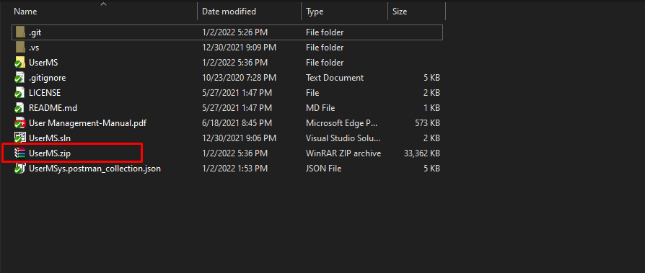

Step 2:
Open UserMS.sln file with Visual Studio 2019
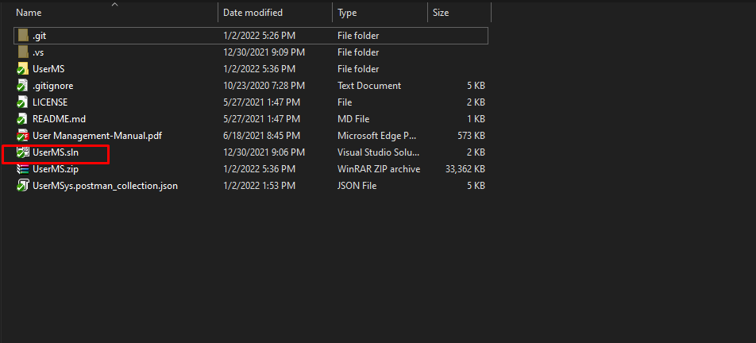
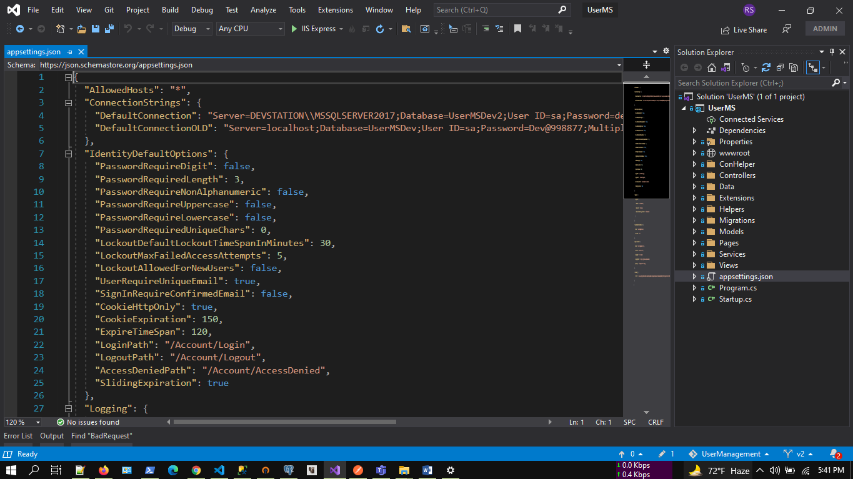

Step 3:
Update database connection: appsettings.json
“DefaultConnection”: “Server=DEVSTATION\\MSSQLSERVER2017;Database=UserMSDev;User ID=sa;Password=dev123456”
Server=Your MS SQL Server Name
User ID= Your MS SQL Server User Name
Password= Your MS SQL Server User Password
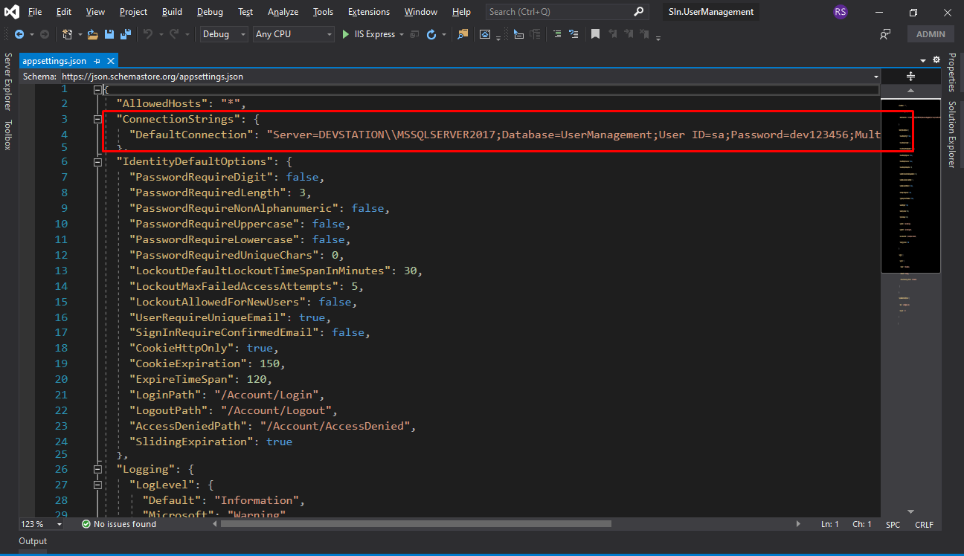

Step 4:
No need to create migration rule and update database. You just need to build and run the application. Already initial migration rule included with project. Please make sure MS SQL server running properly.
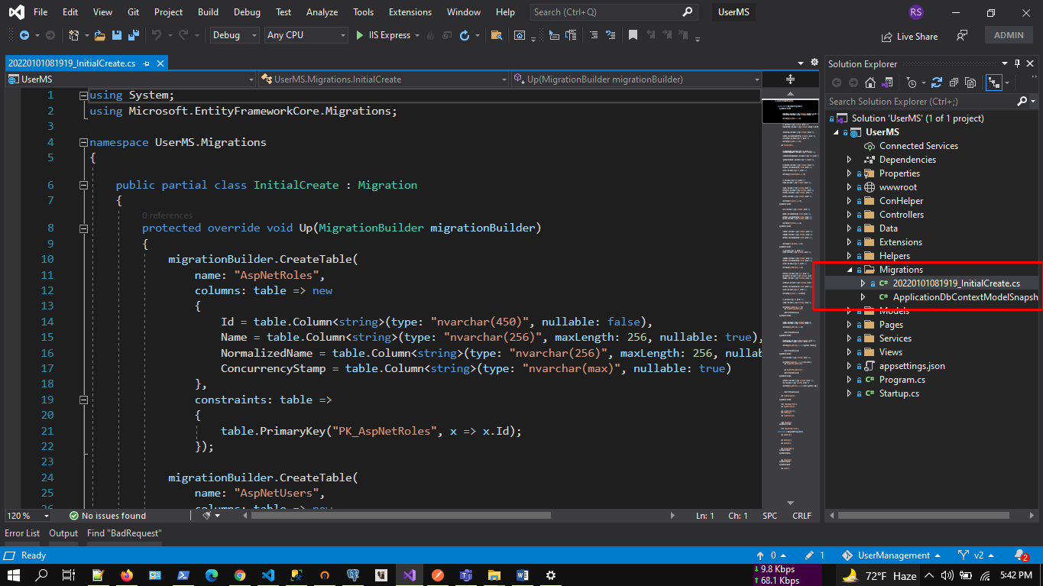

Step 5:
5.1: Build application by pressing f6
5.2: Run application by pressing f5
https://localhost:5013/
Initially in the SQL server, relevant data will be created in the database dynamically as code first approach.

Step 6:
Browse full application.
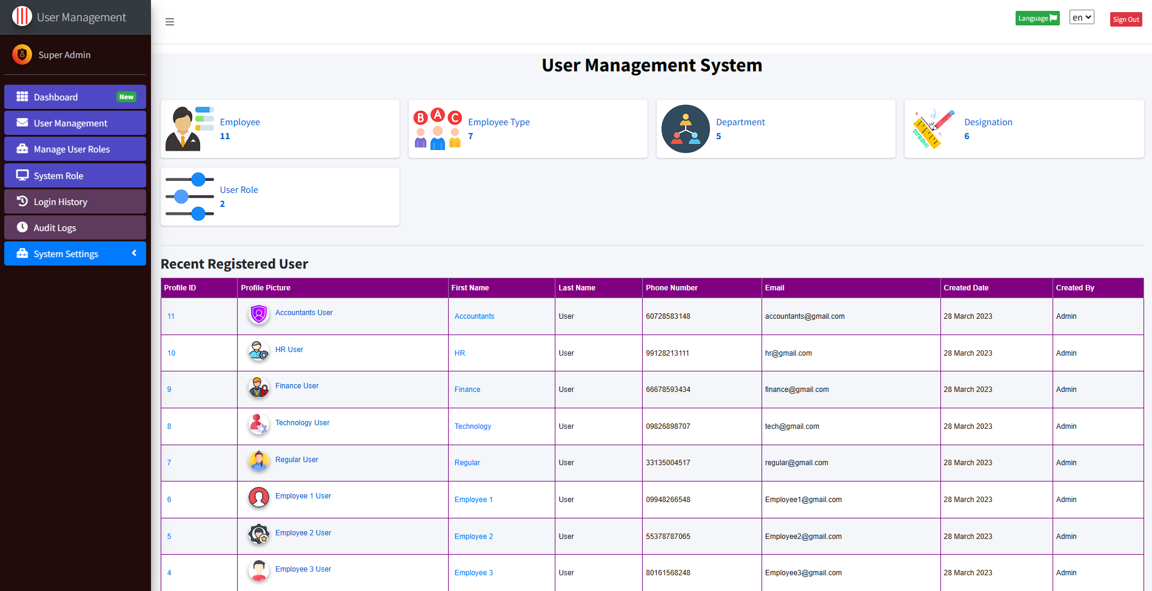

Demo Video Preview
https://www.youtube.com/watch?v=Wi4tcEE27ms&
https://www.youtube.com/watch?v=DZg1-VomYB4&

Key Features:
+ Register New User
+ Reset Password
+ Forgot Password and Recovery
+ Admin Dashboard
+ Recent Registered User
+ User Management: Admin
+ Manage Page Access
+ Email Setting for email notification and confirmation
+ User Profile
+ Identity Setting
+ Login History
+ No Page Loading
+ JWT
+ Swagger

DB Migration:
Tools--> Nuget Package Manager--> Package Manager Console

PM> add-migration initcreate
PM> update-database

Check .Net Version:
Press Windows + R.
Type cmd.
On the command prompt, type dotnet --version

Login:
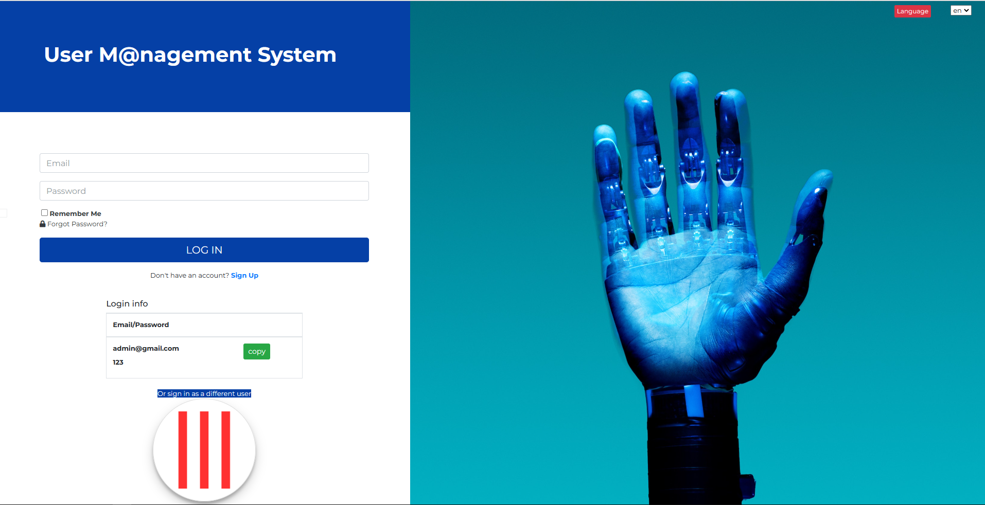

Supports:
If you want to modify or add new features, you can always contact us at,
WhatsApp: 8801674411603
Telegram: shahed71bd
Skype: shahedatomap
Email: shahedbddev@gmail.com

